# Chapter 1: Introduction

## 1.1 Introduction

In today's tech era, Internet has become much popular around the world. Almost all the devices, which are known as smart device, can connect to the internet and access data from any corner of the world. There was a time when people used to waste their valuable time just to get a piece of information. Now the technology is more advance then compare to any previous times. One of the blessings of technology is web application. It allows users to interact with the system from anywhere as long as they are connected to the internet [1].

Here, "Bus Tickets" is completely a web application. As we already discussed above that internet has made the user’s interaction through the system easier, so this web application can connect to respective servers for accessing data which will surely help users to purchase the bus ticket or reserve their seats online without waiting on queue. Moreover, in recent decays peoples are like to travel to get some relief from their monotonous life. So, they want to travel without any hesitations. In this modern tech era, they want a system that will enhance the portability, accessibility as well as user friendly. So here, we are going to implement a web system, which we already stated above, having all the features that will make it more user friendly and accessible.

In this system, we can provide different types of buses. Here, we can manage all types of passenger data & bus data. All details that are related to traveling like fare details, seat availability, details of booking, bus details, seating arrangement, inquiry, etc. The charges are different for different buses. The charges also depend on the distance the customer wants to travel. In this system, we can provide the features to the passenger like the passenger could choose the available seats themselves. This reservation system also provides the admin facilities to send Email & SMS.

This website has various kinds of information that helps regarding booking of tickets. Users will be able to search the bus availability, the exact fare, the arrival and departure time of the bus.

## 1.2 Problem Definition

The Manual bus rental system provides services only during office hours. So, customers have limited time to make any transactions or reservation of the buses. The existence of the online bus rental systems nowadays has overcome the limitation of the business operation hour. However; there is still a few numbers of these online bus rental systems in Nepal and most of the systems offered reservation service for tourists or traveler. Besides that, there are some customers who faced a problem in choosing bus to be rented which suitable with some of the important requirements.

1. To rent a bus a prospective renter must first go to the nearest office to register as a client.
2. Buses that provide difficulties to rent out are normally advertised in local or national newspaper.it involves a lot of paper work and consumes time.
3. With the Dashain Tika hardly a week away, the unavailability of bus tickets has hit the out bound passengers.
4. Passengers complain of being shortchanged after bus fare hike.
5. Choosing right Bus
6. Single ticket for multiple passenger
7. Needs a lot of working staff and extra attention on all the records.
8. In existing system, there are various problems like keeping records of items, seats available, prices of per/seat and fixing bill generation on each bill.
9. Finding out details regarding any information is very difficult, as the user has to go through all the books manually.

## 1.3 Objectives

The proposed web-based system has the following features that will be included in the Online ticketing System. With the proposed system, the achievable advantages are as follows:

1. To view updated accommodation details,
2. To view vehicles with affordable pricing the rental pricing for each type of vehicles.
3. To post suggestions, comments, and complaints the registered and unregistered users are able to post their suggestions, comments and complaints.

## 1.4 Scope and Limitation

### 1.4.1 Scope

1. It allows to see accommodation details,
2. It allows users to book online,
3. It provides an admin to delete users,
4. It reduces the user's time,
5. It provides various buses for booking,
6. It provides a user-friendly environment.

### 1.4.2 Limitations

Some of the limitations that exist in our site are:

1. Users cannot undo the process when seat is booked,
2. User can only choose a single design of mask while buying,
3. Online payment is not present.

## 1.5. Report Organization

This report document contains five chapters including this chapter. Chapter two defines and describes Background Study and Overview of related existing systems and their pros and cons. Chapter three presents the System Analysis and Design including Requirement Analysis and Feasibility Analysis. Chapter four presents the Implementation, Testing and debugging are explained. In chapter five, Conclusion, Limitations and Future Enhancement are briefly explained.

# Chapter 2: Background Study and Literature Review

## 2.1 Background Study

The prevalent view in various global circles is that man is presently living in an age growth of information gathering processing and dissemination, popularly call then information age. For this reason, manager and other user of information especially in transport industries are demanding more kind of information to support management and operations. They must therefore respond to the increasing requirement for information and data management.

Electronic tickets, or e-tickets, gives evidence that their holders have the permission to enter a place of entertainment, use a means of transportation, or have access to some internet services. The design of this online system will be beneficial to the company because it has not existed before.

Currently, staff at the bus ticket counter is using an internal system to sell tickets at the counter and customers who are unable to by bus ticket online at this moment would have to go to the counter to a buy bus ticket. Sometimes, customer’s needs to queue to buy bus ticket and ask for information and this brings a lot of inconveniences to customers.

However, online bus ticket booking system enables the customer to by bus ticket, make payment, and ask for information online easily. Furthermore, staff can sell bus ticket using bus ticket booking system after checking the bus ticket availability for the customer and print the bus ticket to the customer.

## 2.2 Literature Review

### Current Websites providing services on second hand books

There are many websites out there on the internet that provide services. Our goal is to provide a better, faster and user-friendly website with services that other websites might be lacking or not well developed. Our system will only focus on latest products. To get more idea on how to implement the system in our business, we reviewed some available website that have the same type of service and their description can be seen below. Our Bus ticketing system is a free website which allows people to book different vehicles for different places.

### Pros of Online Tickets

1. User can choose Origin and Departure,
2. User can choose different Vehicles for traveling,
3. Users can send their details while booking,
4. You can pay online,

### Cons of Online Tickets

1. It is just an online website, if the user booked the tickets once then, He/she cannot undo it,

# Chapter 3 System Analysis and Design

## 3.1 System Analysis

Before starting any new system development, it is important to plan how it will be developed, tested and maintained. It is a key to success for any project. For the success of the project, the team as a whole were involved in the discussions regarding the development and work flow of the project [2].

### 3.1.1 Requirement Analysis

Requirement analysis is done while developing a system and before implementing it, it is necessary to analyze the whole system requirement. It is categories into mainly two parts:

i. Functional requirements

ii. Non-functional requirements

1. **Functional Requirements:**

* Admin
* Can login
* Can delete all users
* Can update the accommodation
* Can accepts users Bookings
* Can reject the bookings
* Can add Bus
* Users
* can see accommodations list
* Can send their information’s while booking

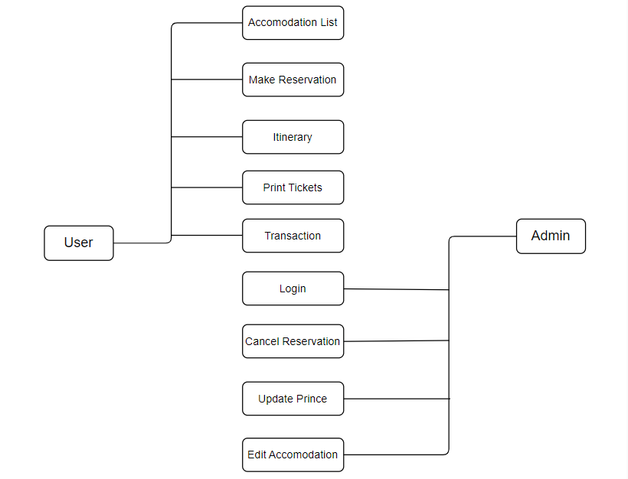

**Figure 3.1: Use case Diagram**

### Non-Functional Requirements

* Security: This system has accounts for its users and only authorized users can access the system with username and password. The passwords are encrypted using a PHP function md5 ().
* Availability: This system is available to users anytime, anywhere, just need a PC or Mobile and Internet Connection. Also, the system works in multiple web browsers like (Chrome, Mozilla and Opera).
* Reliability: The system has to be 100% reliable due to the importance of data and the damages that can be caused by incorrect or incomplete data. The system will run 7 days a week, 24 hours a day. This system provides a quick and efficient mask of required information. Any type of mask would be available whenever the user requires.
* Maintainability: The system will be easily maintained by the developer or other authorized trained person and Backup for databases are available.

### 3.1.2 Feasibility Analysis

As the name implies, a feasibility analysis is used to determine the viability of an idea, such as ensuring a project is legally and technically feasible as well as economically justifiable. It tells us whether a project is worth the investment. Following feasibility analysis was performed prior to working on the project:

1. **Technical**

All the software development tools required are readily available so it is technically feasible. In order to design this system, the basic requirements on a software and hardware are a laptop or a personal computer. Following are the skills that one should have to develop this system:

**Front end**

* HTML 5
* CSS 3
* JavaScript ES2015
* Bootstrap 5

**Back end**

* PHP 8.0.8 **Database**

1. **Operational**

All the required operations such as internet service are available and there isn’t any legal issue. So, this project can be considered operationally feasible.

1. **Economic**

This project is developed using software selling kits of which all are open-source, so it does not incur any costs. Hence, this project is economically feasible and can be implemented easily.

1. **Schedule**

The time for developing this project is 7 weeks which is enough with 2 human resources.

|  |  |  |  |  |
| --- | --- | --- | --- | --- |
| **ACTIVITIES** |  | |  |  |
| **I** | **II** | **III** | **IV** |
| Project Analysis |  |  |  |  |
| Proposal submission |  |  |  |  |
| Component collection |  |  |  |  |
| Design Verification |  |  |  |  |
| System Validation |  |  |  |  |
| Coding &  Implementation |  |  |  |  |
| Unit testing |  |  |  |  |
| Final testing |  |  |  |  |
| Documentation |  |  |  |  |
| Final Project  Submit |  |  |  |  |

**Figure 3. 2****Gantt Chart**

In scheduling feasibility, an organization estimates how much time the project will take to complete. To calculate and continually re-examine whether it is possible to complete all the amount and scope of work lying ahead, utilizing the given number of resources, within the required period of time. In our project we used the Gantt Chart for the Schedule feasibility study.

#### 3.1.3 Data Modeling (ER-Diagram)

This ER (Entity Relationship) Diagram represents the model of this project. The entity-relationship diagram of the project shows all the visual instruments of the database table and the relations between admin, accommodation, and users etc. It uses structured data to define the relationship between structured data groups.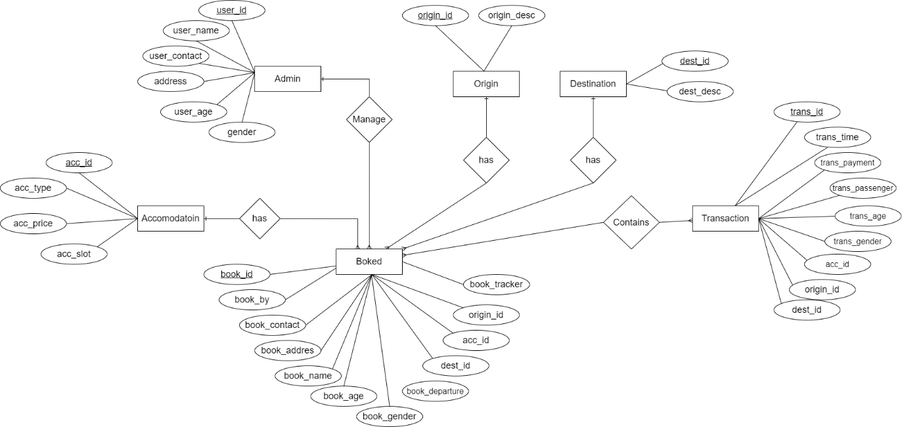

### Figure 3.3: ER Diagram

In the above ER Diagram, we can clearly see all the relation between the entities. There are a total seven entities in this project and they have their respective attributes too. Here we can see admin can login in system where login has their own attributes. As in the diagram Admin can manages Transaction, Reservation, Origin, Destination and Accommodation. All of the entities have their attributes. So, we can clearly observe the Entity Relation between all the above entities.

#### 3.1.4 Process Modeling (DFD)

Data Flow Diagrams show the flow of data from external entities into the system, and from one process to another within the system. Following are the Data Flow Diagrams for the current system. Each process within the system is first shown as a Context Level DFD and later as a Detailed DFD. The Context Level DFD provides a conceptual view of the process and its surrounding input, output and data stores. ([3], What is DFD) The Detailed DFD provides a more detailed and comprehensive view of the interaction among the sub processes within the system. Which is explained below in figure. 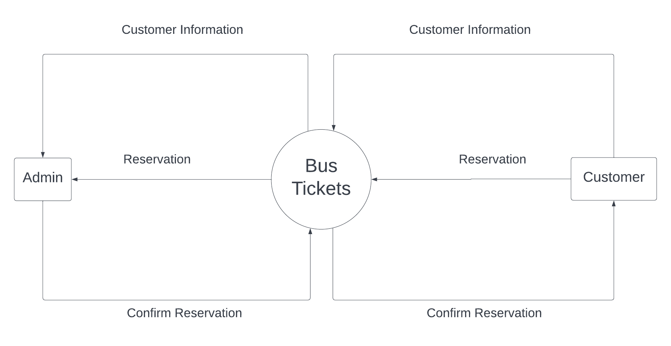

### Figure 3.4: Context Diagram/ DFD-0

The above picture represents DFD Level 0 of our application. The functionalities that can be done by the admin and customer is roughly shown in the figure as well as the link of our application with the database is also shown in the figure. The main functionalities of our system are Reservation and customer information.

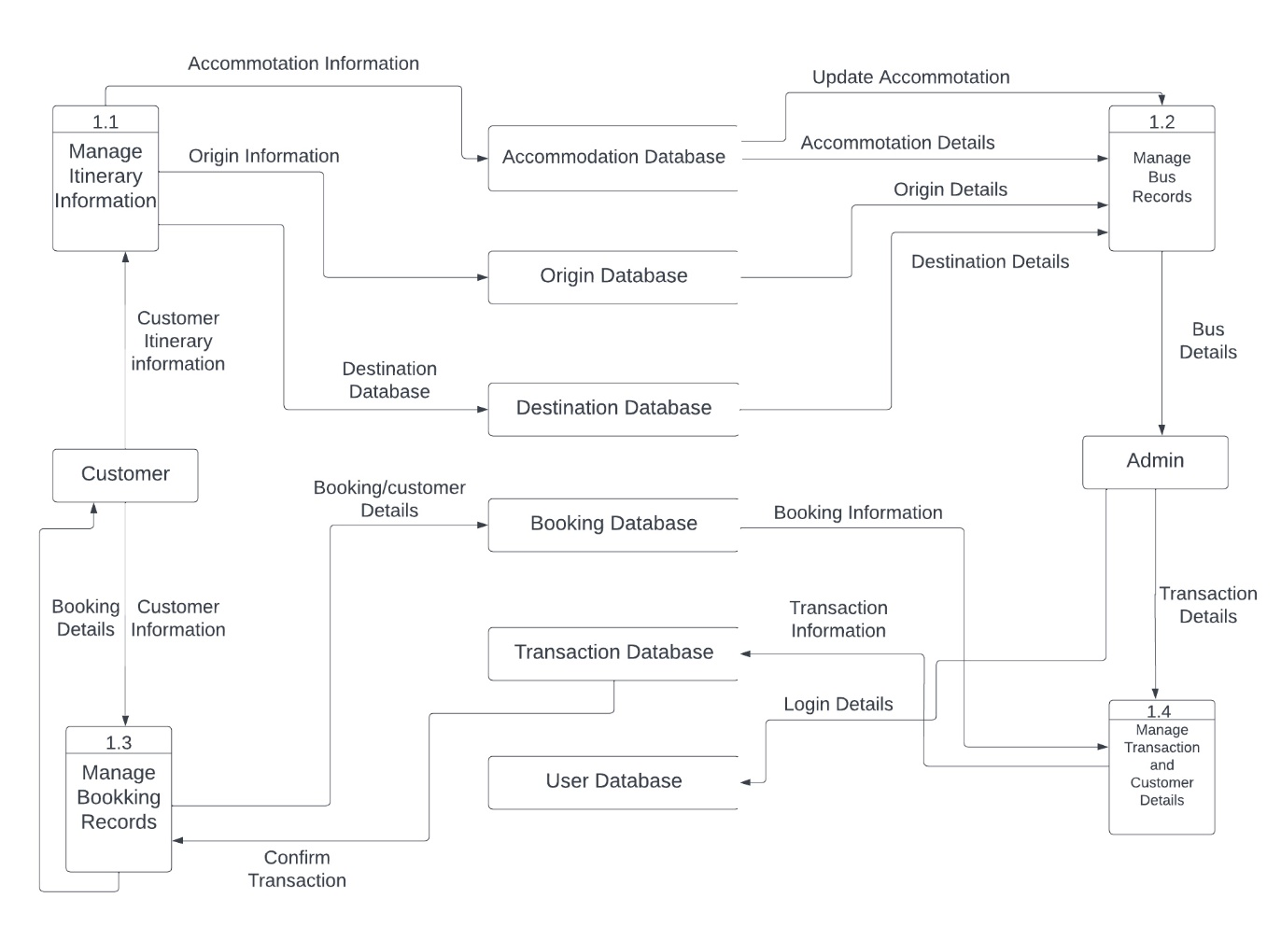

### Figure 3.5: DFD Level-1

In the above DFD Level-1 we can see all the operations that can be done by the admin, and Customer. Here the Admin can manage Accommodation, Destination and Origin, whereas the admin should log into the system.

## 3.2. System Design

### 3.2.1. Architectural Design

Below is the figure for Architectural Design of this system.

Load main value

Enter Valid password

Enter to admin

Enter detail for the task

Verify detail

Another task

Data base

Display report

Update detail and process report

Print report



**Figure 3.6: Architectural Design**

### 3.2.2. Database Schema Design

Below is the diagram for Database Schema Design of this system.

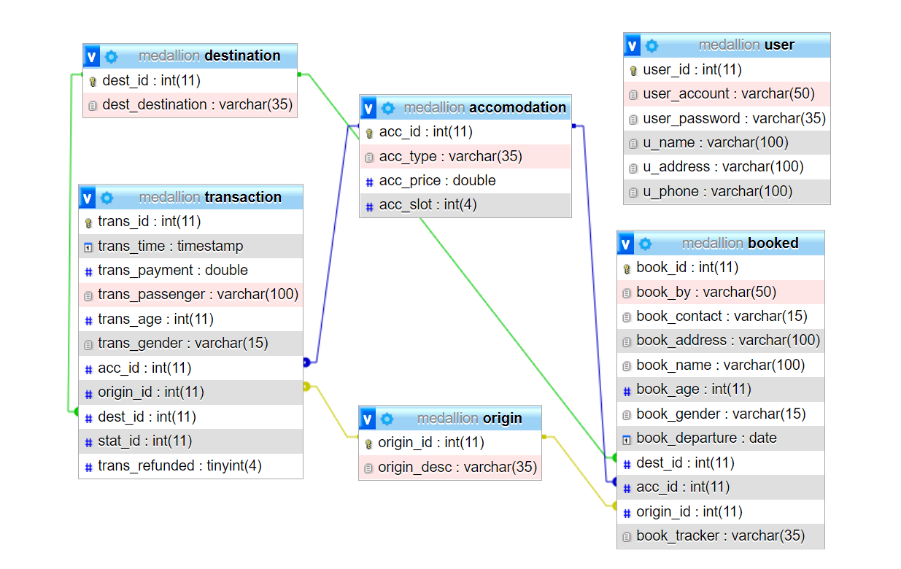

**Figure 3.7: Database Schema Design**

#### 3.2.3 Interface Design (UI Interface / Interface Structure Diagrams)

Before implementing the actual design of the project, a few user interface designs are constructed to visualize the user interaction with the system. The user interface design will closely follow our Functional.

### 

### Figure 3.8: Home Page of online tickets

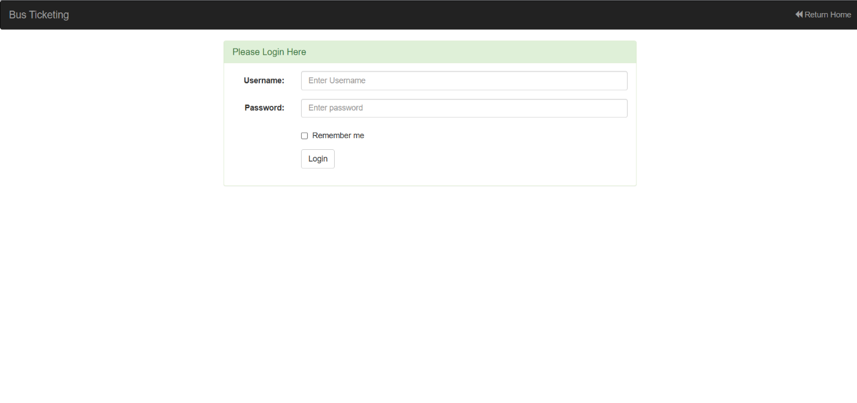

**Figure 3.9: Login Page of Online Tickets**

### 

### Figure 3.10: Reserved Data

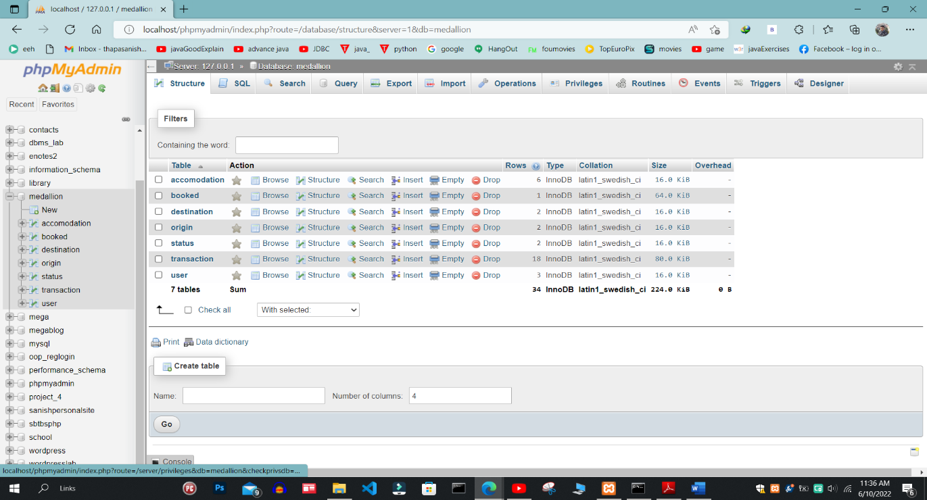

**Figure 3.11: Database of online tickets**

# Chapter 4: Implementation and Testing

## 4.1. Implementation

### 4.1.1. Tools Used

Some of the CASE Tools used while developing the website are Figma (for UI design), Navi cat (for Database design), and GitHub (as a repository).

And the system is developed using HTML, JavaScript and PHP Languages. The database used to store the data is MySQL. Also, the framework of CSS “Bootstrap” is used to make design looks better. And jQuery, jQuery-UI are used to make website dynamic.

### 4.1.2. Implementation Details of Modules

**function addTransaction($pay, $pass, $age, $gen, $acc_id, $orig_id, $dest_id)**

This is the one of the functions used in the system which is written in PHP Language. It is used to insert data in the database table to record the data entered by the users about their general information. there are also other function such as selectBook($book_id), function getAllBook(), function getAllAccomodation(), getPassengers($tracker) to keep respective data of the users.

## 4.2. Testing

Below is the table with testing cases and result that we have done on this system

|  |  |  |  |  |  |  |
| --- | --- | --- | --- | --- | --- | --- |
| **Test Case**  **ID** | **Test Case Description** | **Test Steps** | **Test Data** | **Expected Results** | **Actual Results** | **Pass / Fail** |
| T01 | Check Reservation with valid Data | 1.Go to Home page  2.Enter Reserve Now  3.Choose Origin and Destination  And Date  4.Click Next | Origin = Kathmandu  Destination = Pokhara  Departure Date = 2022-09-17 | User should successfully enter next step | As Expected | Pass |
| T02 | Check Reservation with invalid Data | 1.Go to Home page  2.Enter Reserve Now  3.Choose Origin and Destination  And Date  4.Click Next | Origin = Kathmandu  Destination = Pokhara  Departure Date = Null | User should not successfully enter next step | As Expected | Pass |
| T03 | Select Accommodation and Total Passenger | 1.Go to Reservation  2.Fill the valid Data  3.Click Next  4.Select the Accommodation and Total Passenger  5.Click Next | Accommodation = SUMO X1  Total Passenger = 1 | User should successfully enter passenger info page | As Expected | pass |
| T04 | Fill the all fields with proper information | 1.After entering Passenger info section  2.Fill all the information  3.Select the Gender  4.Click Next | Booked By = KP Sharma Oli  Contact = 9876543219  Address = Bikash Pole Kathmandu  Email = kpsharmaoli@gmail.com  Full Name:(1) = Kate Winslet  Age:(1) = 35  Gender:(1) = Female |  |  |  |
| T05 | Check Admin Login with valid Data | 1.Go to Home page  2. Enter Username and Password  3. Click Login | Username  = user    Password  = user | User should Login into the system | As  Expected | Pass |
| T06 | Check Admin Login with invalid Data | 1.Go to Home page  2. Enter Username and Password  3. Click Login | Username  = fake    Password  = fake | User should not Login into the system | As  Expected | Pass |
| T07 | Accept Reserved Data | 1.Go to this link ://localhost/project1/ticket%20reservation3/admin/reservation.php  2.Click on accept paid Reserved Data  3.Click Accept | Transition Save Successfully | Admin should successfully accept reserved Data | As Expected | pass |
| T07 | Cancel Reserved Data | 1.Go to this link http://localhost/project1/ticket%20reservation3/admin/reservation.php  2.Click on Cancel unpaid Reserved Data  3.Click Conform | Reservation Delete Successfully | Admin should successfully Cancel reserved Data | As Expected | pass |
| T08 | Edit Bus Detail | 1.Go to this link <http://localhost/project1/ticket%20reservation3/admin/BusDetails.php>  2.Select particular bus detail  3. Click on Edit  4. Fill all the info | Name = ULTRA SUPER  Price = 500  Total Slots = 33 | Successfully Update | As Expected | pass |
| T09 | Check Logout Button | 1.Go to this link  <http://localhost/project1/ticket%20reservation3/admin/reservation.php>  2.Click logout Button |  | Admin successfully logout | As Expected | pass |

# Chapter 5: Conclusion and Future Recommendations

## 5.1. Conclusion

It can be observed that computer applications are very important in every field of human endeavor. Here all the information about customer that made reservation can be gotten just by clicking a button with this new system, some of the difficulties encountered with the manual system are overcome. It will also reduce the workload of the staff, reduce the time used for making reservation at the bus terminal and also increase efficiency. The application also has the ability to update records in various files automatically thereby relieving the company’s staff the stress of working form file security of data. This project, as a whole, will give a new way in bus reservation and ticketing processes. The automation and management of seats and reservation will be done online. However, this project does not limit the walk-in passengers that is passengers who visit the company’s counter because it also caters for them. This also lessens the use of papers like in the traditional way of ticketing.

## 5.2. Recommendations

Research and development are continuous processes; this is the same in computer and software development. The system can contribute more on those bus representatives handling the account if it can generate reports by trip so that they will no longer go to a certain module to check the reservation and its details. Also, it will be more beneficial to both clients and bus representatives if clients can create an account just like in airlines websites. With that, the system can record the modifications made. Other functionalities such as E-Mail facility for sending Ticket to passenger, Online Payment with Credit Card / Debit Card etc. could also be integrated into the system in order to enhance user friendliness and interactions.

**References**

[1]Dataflow diagram reference available at: [Online Bus Ticket Reservation System (researchgate.net)](https://www.researchgate.net/publication/326468848_Online_Bus_Ticket_Reservation_System)

[2][**https://www.google.com/url?sa=t&rct=j&q=&esrc=s&source=web&cd=&cad=rja&uact=8&ved=2ahUKEwijkIO8qNz2AhURAd4KHTAaC2YQFnoECAUQAQ&url=https%3A%2F%2Fcore.ac.uk%2Fdownload%2Fpdf%2F234644905.pdf&usg=AOvVaw39vZzJuOPQ6_F2eE75oSpg**](https://www.google.com/url?sa=t&rct=j&q=&esrc=s&source=web&cd=&cad=rja&uact=8&ved=2ahUKEwijkIO8qNz2AhURAd4KHTAaC2YQFnoECAUQAQ&url=https%3A%2F%2Fcore.ac.uk%2Fdownload%2Fpdf%2F234644905.pdf&usg=AOvVaw39vZzJuOPQ6_F2eE75oSpg) **-PDF**

[3]For learning HTML, CSS, JS and SQL[W3Schools Online Web Tutorials](https://www.w3schools.com/?msclkid=461cfdafaaad11eca556808d813a4320)